Linear Regression python implementation (jupyter).

* [1] Download python code from github: <https://github.com/m0-k1/Linear-Regression_model>

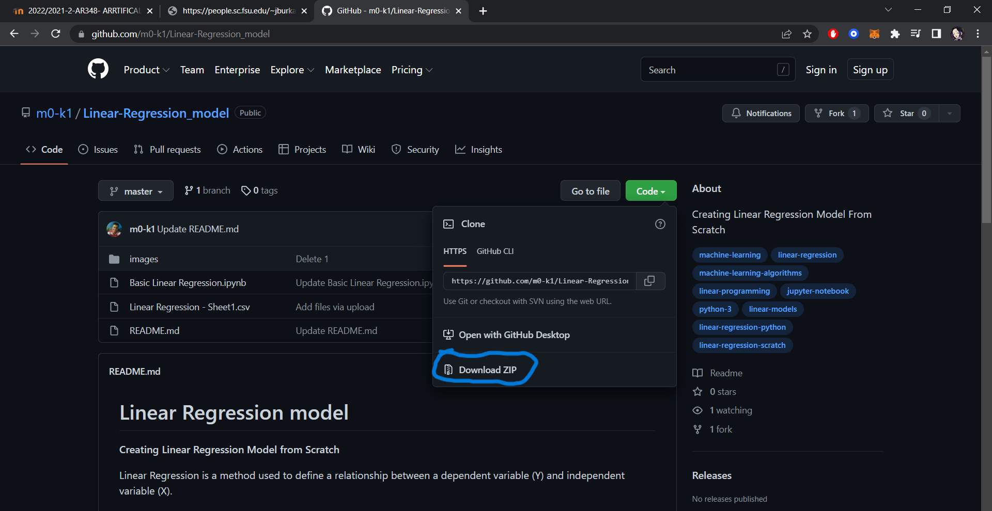

* [2] Copy the dataset x14.txt (gas tank temperature and pressure) from : <https://people.sc.fsu.edu/~jburkardt/datasets/regression/x14.txt?fbclid=IwAR2MavxvsyUGFBetPLsQCSEi81E07umhUcX4b4afjgX7zdopmGlHFsOIYpk>

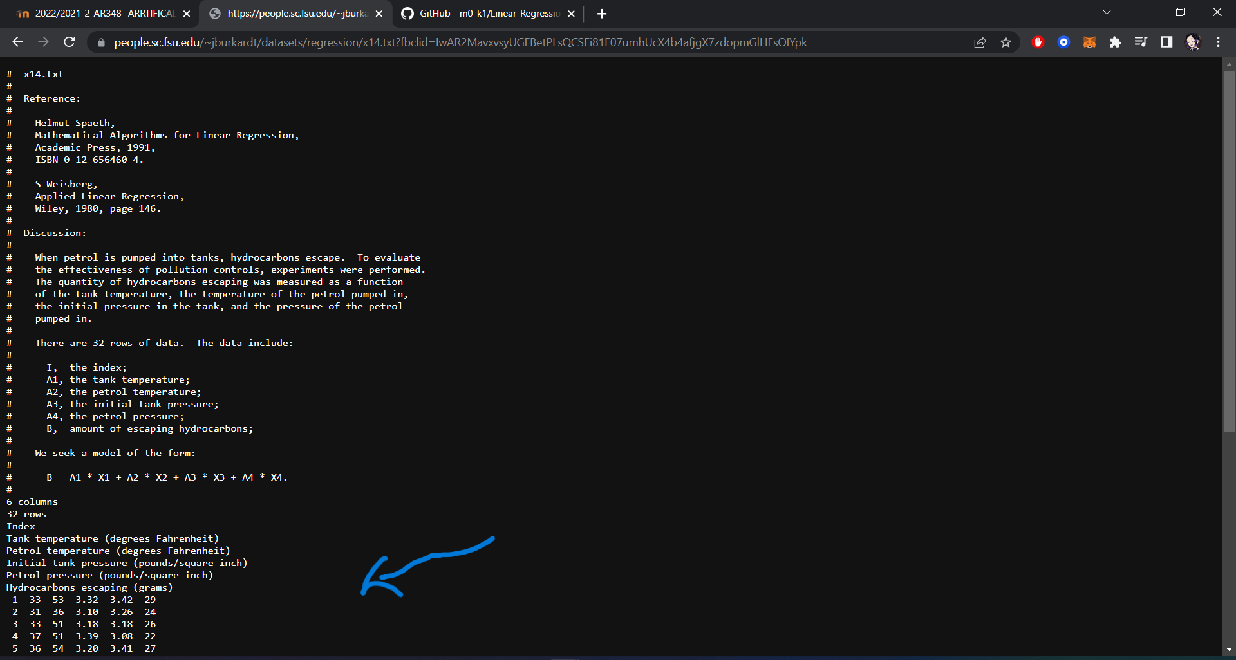

* [3] put the data set in excel file then modify the data set by delete tow columns(Petrol temperature & Petrol pressure) and organize (Tank temperature & Initial tank pressure) in tow different columns and name them X & Y.

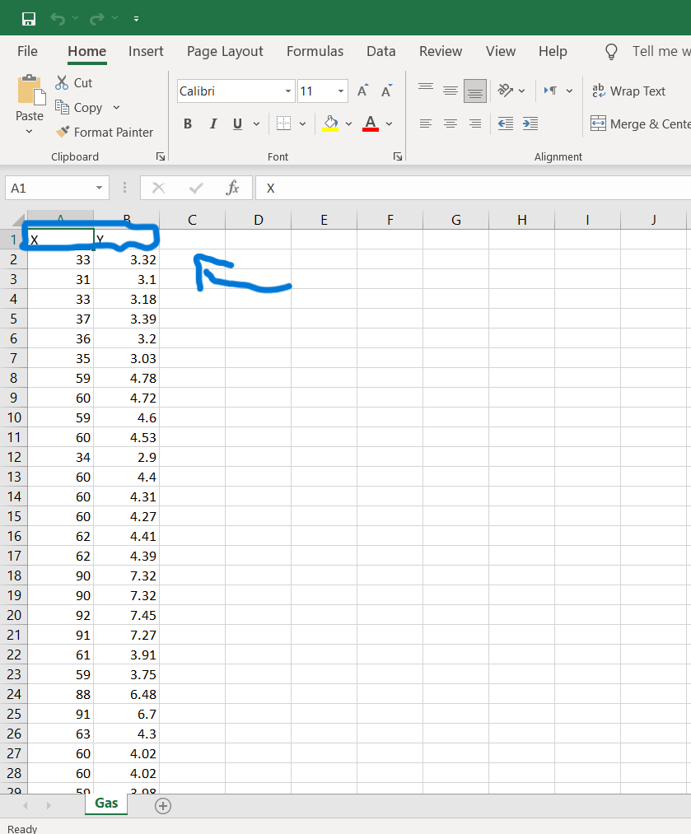

* [4] after preparing the data convert the file from .xlsx to .csv then put the file in the same file of python code.

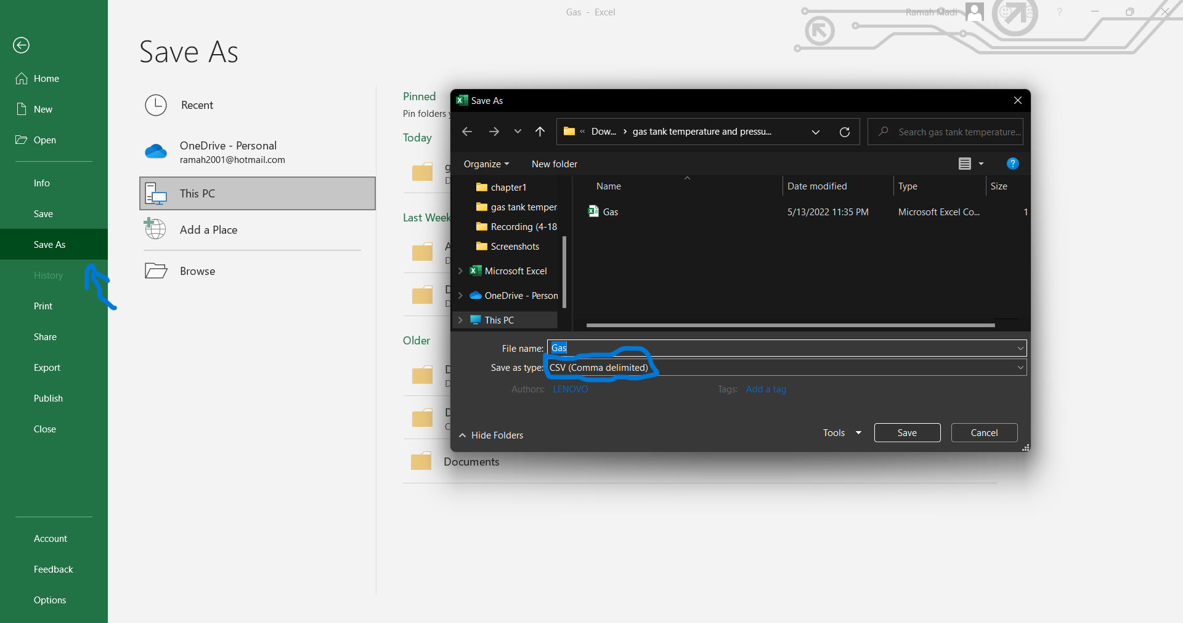

* [5] open jupyter notebook and (Basic Linear Regression).

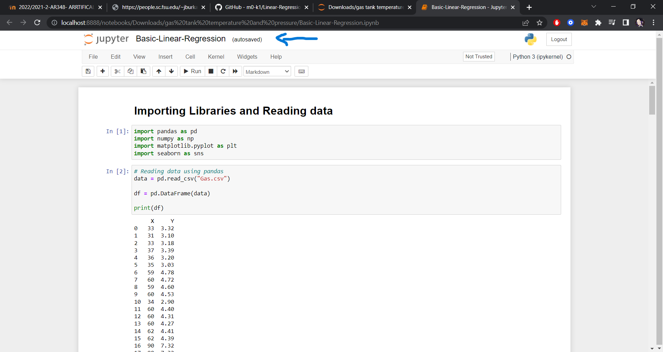

* [6] modify this line of code between " " to the name of my file .csv name (data = pd.read_csv("Gas.csv")).

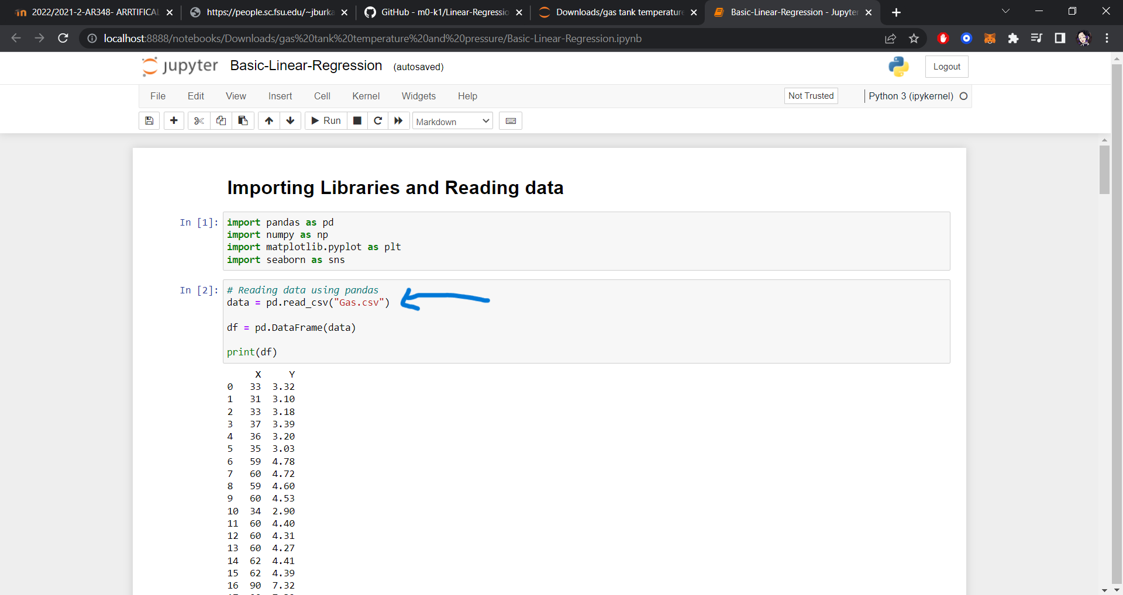

* [7] Add tow line of code (df = pd.DataFrame(data) & print(df)) to visualize my data.

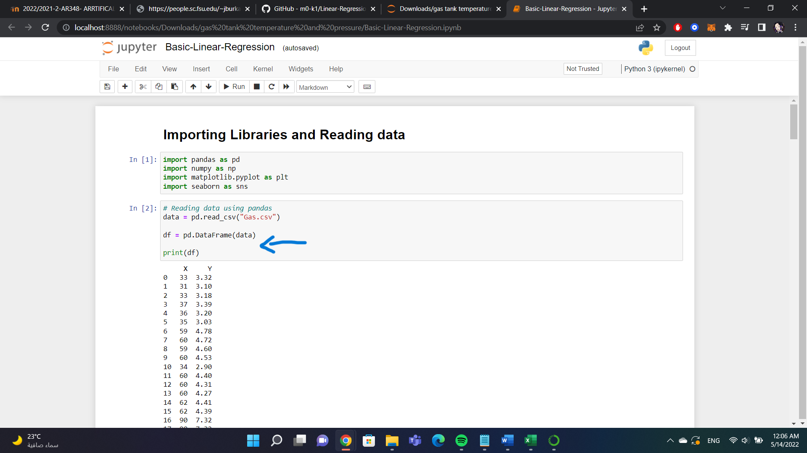

* [8] Run the code!

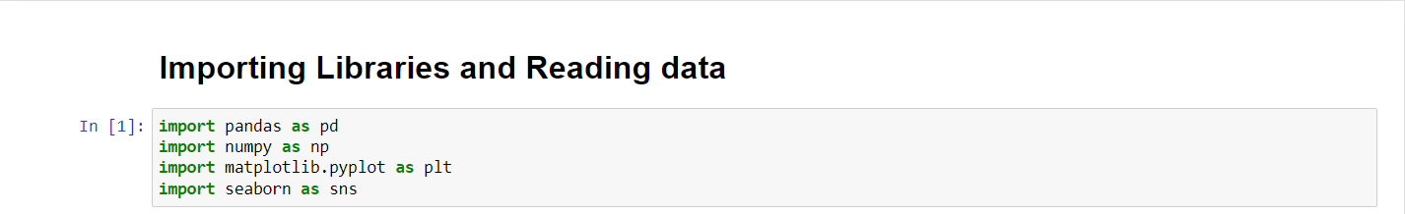

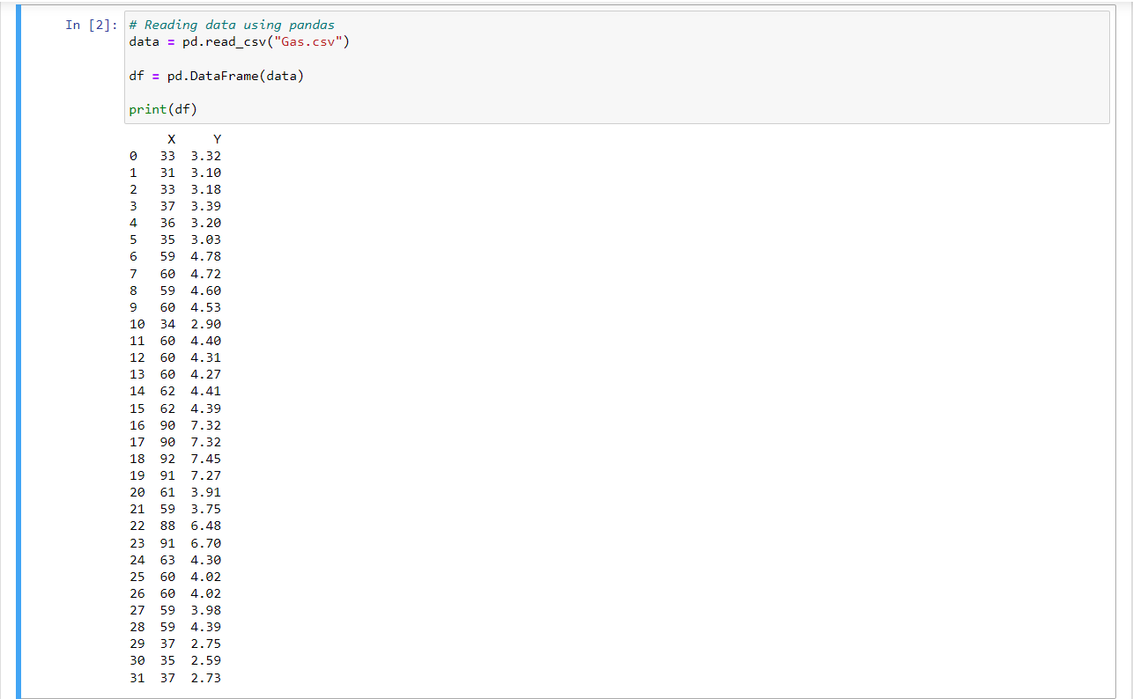

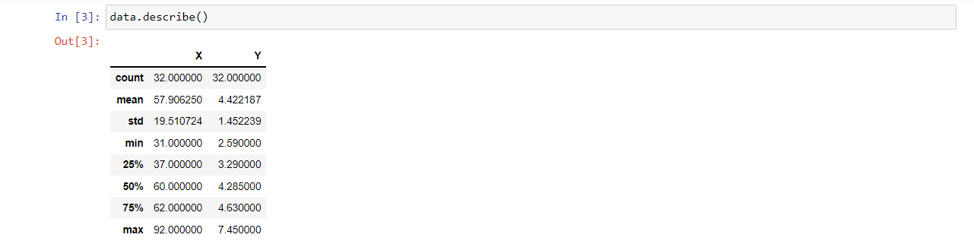

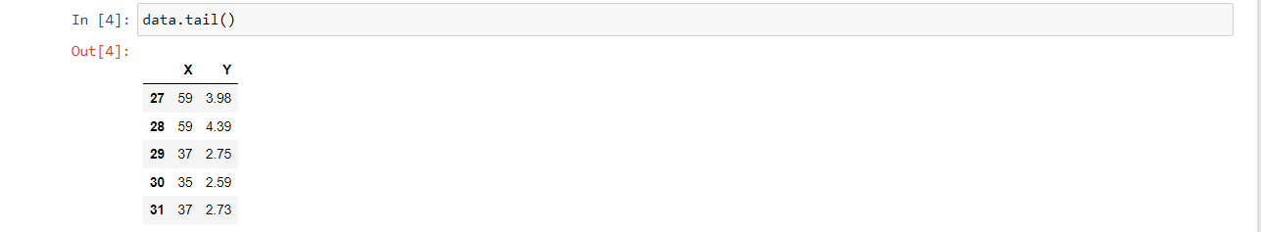

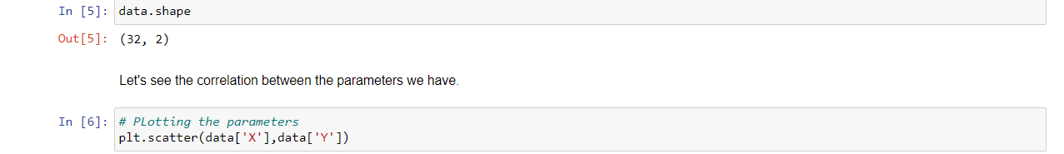

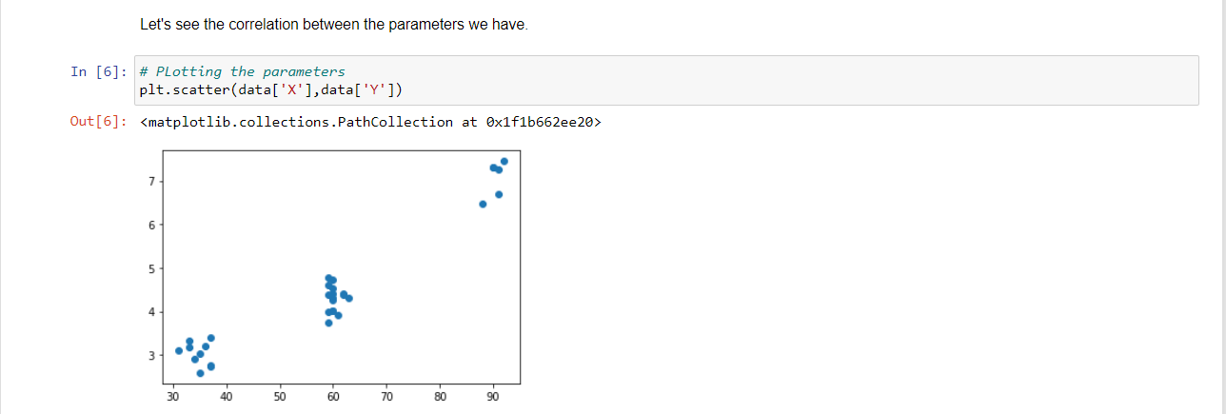

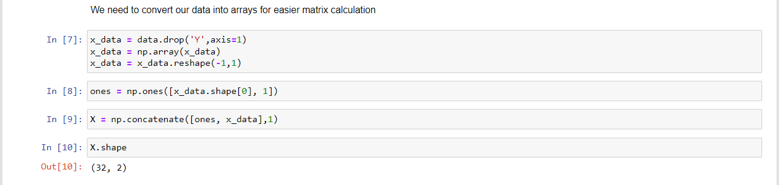

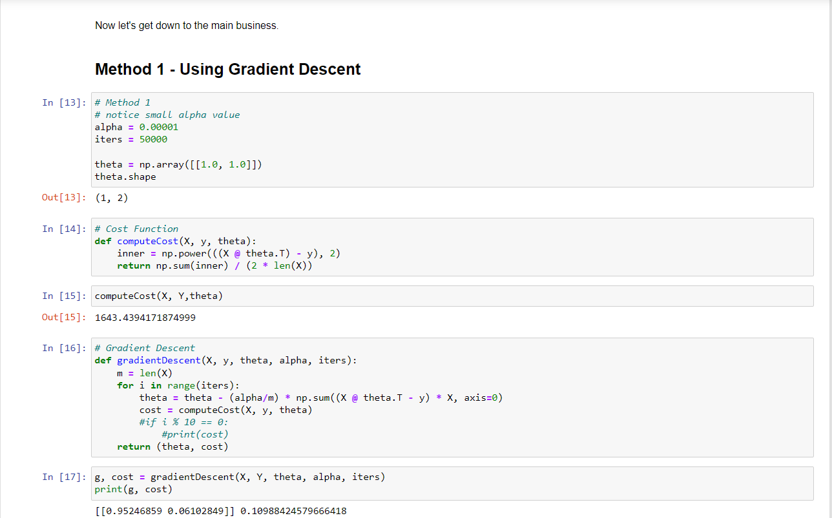

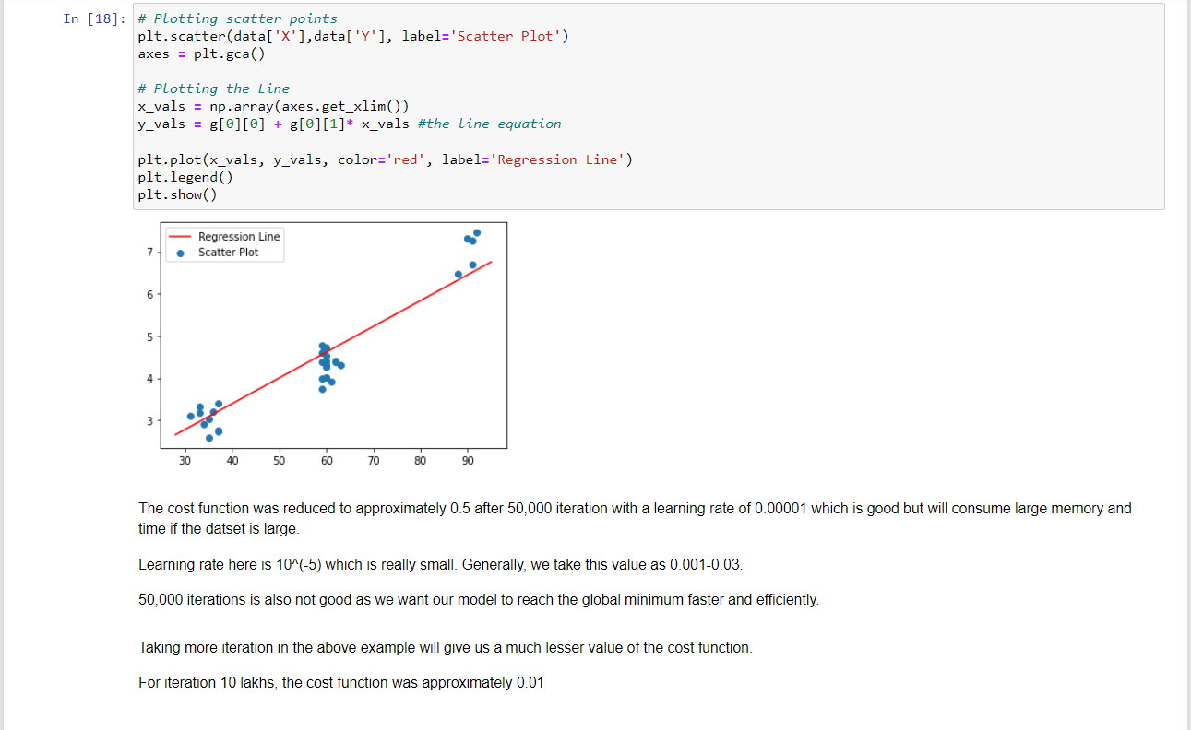

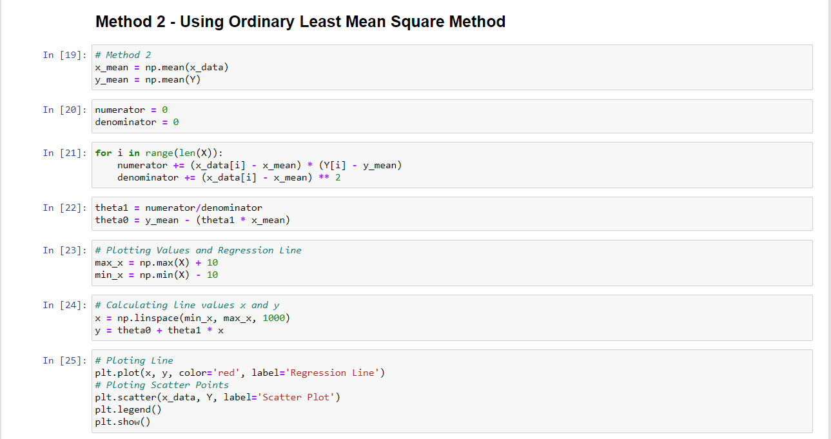

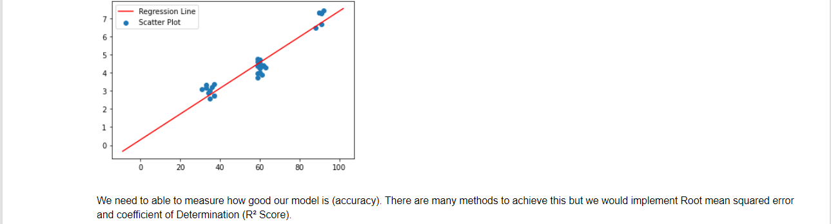

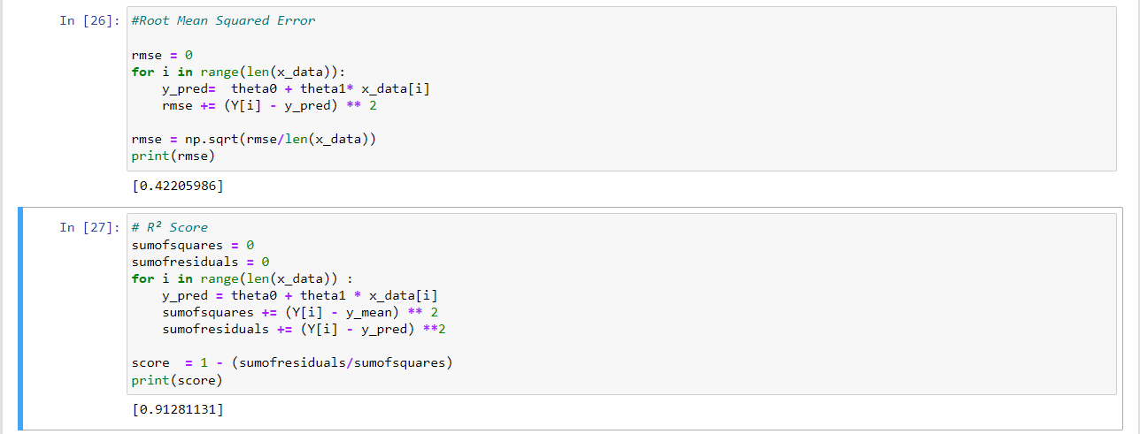

### Name : Ramah hashem madi

### ID no. : 31909303044